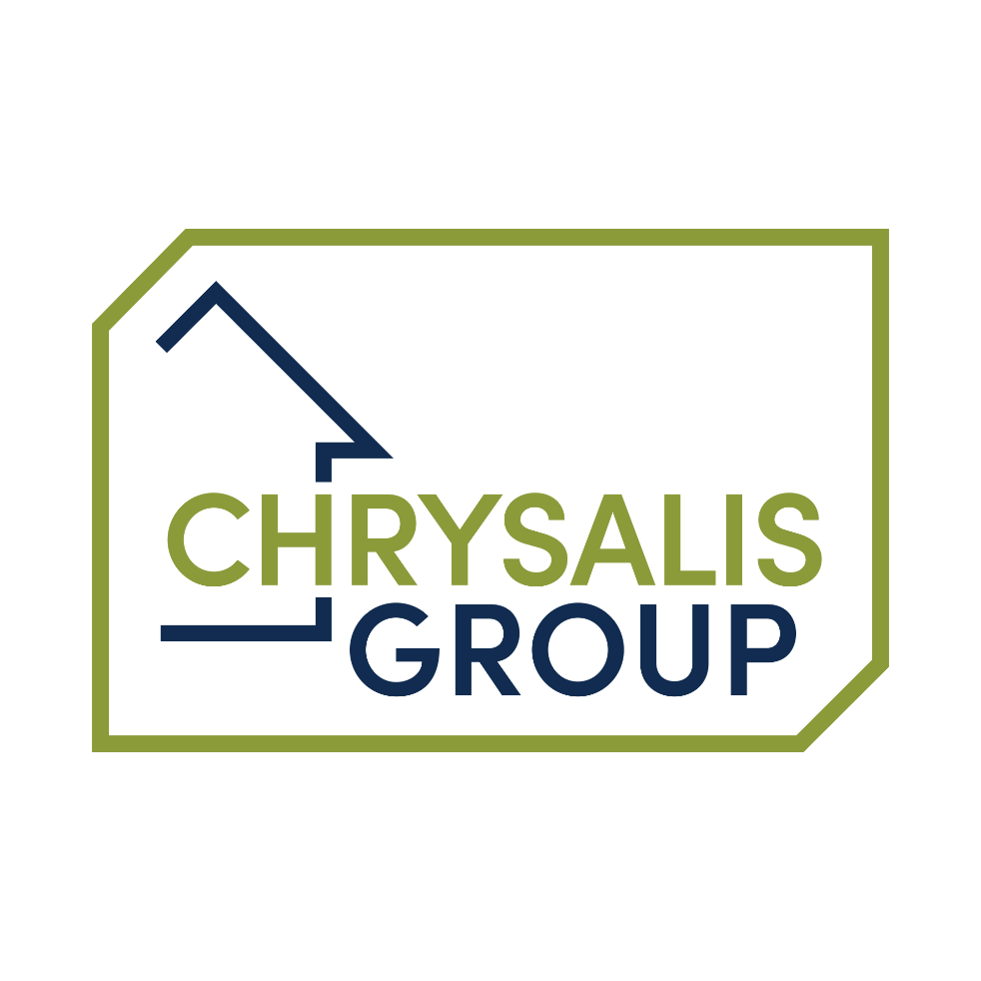

CHRYSALIS GROUP & SUBSIDIARIES

Chrysalis Group Services Limited
Touchstone Investments & Developments Limited
Chrysalis Supported Housing Limited
Opoka Charitable Incorporated Organisation
Compass Project CIC
Blackfields Furniture Ltd

Governance Framework

March 2024

1 Statement of Principles of Good Governance

2 Structure of Chrysalis Group
2.1 Overview
2.2 Regulatory Framework
2.3 Objects, Vision and Values

3 Roles and Responsibilities
3.1 Who can be a Board Member? – Eligibility
3.2 Board Responsibilities

Delegation of Authority/Financial Regulations
3.4 Role Descriptions
3.5 Code of Conduct for Board members

4 Board Recruitment, Appointment, Induction and Development
4.1 Overview
4.2 Induction, Training and Development Support for NEDs
4.3 Appraisals
4.4 Succession-planning
4.5 Skills Evaluation
4.6 Continuity and succession

5 Rules of Group Companies
5.1 Chrysalis Group Services Articles of Association
5.2 Chrysalis Group Rules
5.3 Touchstone Developments & Investments Ltd Articles of Association
5.4 Opoka CIO Rules
5.5 Compass Project 2012 Rules

6 Improving Governance
6.1 Overview
6.2 Registers

SECTION 1 - Statement of Principles of Good Governance

In 2021, the ISO published a new standard, The ISO 37000:2021 Governance of Organisations Guidance which says: “Good corporate governance not only fosters an environment of trust, transparency, and accountability, it also helps align an organisations purpose with the interests of society, building strong stakeholder relationships while effectively managing and maintaining its resources. In this way, good governance lays the foundation for the long-term success of organisations. It ensures they contribute to protecting and restoring social, economic and natural environmental systems.

The Board of Directors of Chrysalis Group Services Limited and the subsidiary boards recognise their obligations to ensure that sound governance arrangements are effectively maintained to meet the highest standards demanded by the law and exemplified by best practice for a housing provider.

The boards will achieve this by regularly reviewing their processes and documentation in the light of the changing needs of both Chrysalis Group Services and each individual entity within the Chrysalis Group (Chrysalis) within the environment in which they work.

Chrysalis is committed to the seven principles of good governance in line with its adopted code of governance: The Charity Governance Code. Although the group is a mix of commercial and ‘not for profit’ organisations the board have decided this is the best code to represent the governance standards the group requires as a whole. It is also clear that all governance codes have many elements in common. Variations will be applied where appropriate on a company by company basis but these will be documented with the reasons.

Governance is the way in which an organisation ensures that it fulfils its overall purpose, achieves its intended outcomes for its customers and operates in an effective, efficient and ethical manner, providing good quality services and achieving value for money.

The Charity Governance Code

The seven principles build on the assumption that Chrysalis is meeting its legal and regulatory responsibilities as a foundation.

Foundation: The Board member role and charity context

It is the Code’s starting point that all Board members:
- are committed to their cause and have joined its board because they want to help the Group deliver its purposes most effectively for public benefit
- recognise that meeting the stated public benefit for some members of the Group is an ongoing requirement
- understand their roles and legal responsibilities, and, in particular, have read and understand:
  - the Charity Commission’s guidance The Essential Board member (CC3)
  - their Group organisation’s governing document

1. Organisational purpose
The boards are clear about the Group’s aims and ensures that these are being delivered effectively and sustainably.

2. Leadership

Every organisation within the Group is led by effective management structure reporting to the main Group Board that provides strategic leadership in line with the Group’s aims and values. Opoka CIO and Chrysalis Supported Association (CSA) have their own board structures offering an appropriate level of independence to ensure their individual aims are achieved without any conflict.

3. Integrity

The main Group Board, subsidiary boards and board subcommittees act with integrity, adopting values and creating a culture which help achieve the group wide charitable and commercial purposes. The board is aware of the importance of the public’s confidence and trust in socially focused ‘not for profit’ organisations and the associated commercial companies, and Board members undertake their duties accordingly.

4. Decision-making, risk and control
The boards make sure that their decision-making processes are informed, rigorous and timely and that effective delegation, control and risk assessment and management systems are set up and monitored. Each board has an effective management and staff structure below the Executive Director with clearly defined roles and responsibilities.

5. Board effectiveness
The Executives and each board work as an effective team, using the appropriate balance of skills, experience, backgrounds and knowledge to make informed decisions.

6. Diversity
The board’s approach to diversity supports its effectiveness, leadership and decision-making. As each board has a different focus and / or target beneficiary group this determines the allocation of services. However, outside the special needs identified all protected groups are treated equally.

7. Openness and accountability
The Group Board leads the organisation in being transparent and accountable. The Group organisations are open in their work, unless there is good reason for it not to be.

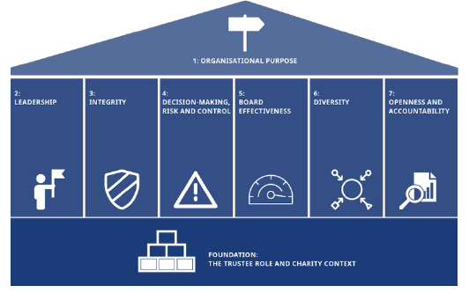Figure 1: An illustration of the principles of the Charity Governance Code
Section 2 – Structure of Chrysalis Group

Chrysalis Group is a group of organisations as shown in the structure below. Within the group there is a Charitable Incorporated Organisation, a provident Society that is also a registered Housing Landlord and a Charitable Incorporated Company as well as commercial limited companies. It is therefore essential that the Governance Framework used within the Group is fit for all the entities and their stakeholders and recognises the regulatory requirements of each organisation within the group.
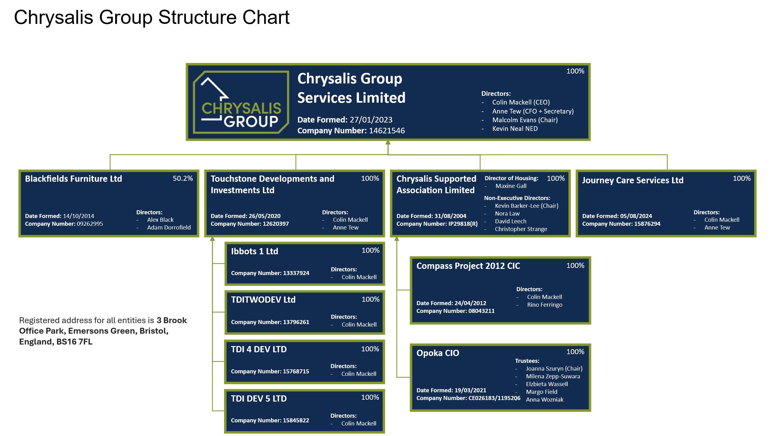

Chrysalis Group Services Limited (CGS) has 4 direct subsidiaries including Chrysalis Supported Assocation Limited (CSA). 3 are 100% owned by CGS, however, the ownership in Blackfields Furniture Ltd is on a majority basis. Within the Group, CSA has two wholly owned subsidiaries, Opoka CIO and The Compass Project 2012 Ltd. Both CSA and Opoka operate their own independent Boards to ensure good governance. CGS acts as the overarching supervisory board consisting of two Executive and two non-executive members. CSA and Opoka only have unpaid and independent Non Executive Directors (NED’s) and Trustees. In both cases, the main executive role does not sit on the board although they attend in an advisory capacity. The management teams have delegated responsibility for the day-to-day running of the relevant organisation but the ultimate responsibility will sit with the Chrysalis Group Board.

The Group Board is currently supported by a Group Treasury, Audit and Risk sub-committee and a Group Nomination and Remuneration committee. CSA has its own independent Audit and Risk Committee.

The Board members delegates some of their powers or functions to an ‘Executive Committee’. An executive committee has delegated authority to act on the Board members’ behalf, in line with their terms of reference and any other instructions the Board members give. An executive committee has decision-making powers so long as the committee is quorate.

The Board members may also establish “Advisory Committees” of experts in a particular field and/or representatives of the organisations’ stakeholders to advise the Board members
.
The current Group Committee structure is as follows:

The following committees have Terms of reference as follows:
5.1 Chrysalis Group Audit and Risk Committee (CM10)
5.2 Chrysalis Group Remuneration and Nomination Committee (CM09)
5.3 Chrysalis Supported Association Audit and Risk Committee (CM10a)
5.4 Chrysalis Group Executive Committee (CM20)

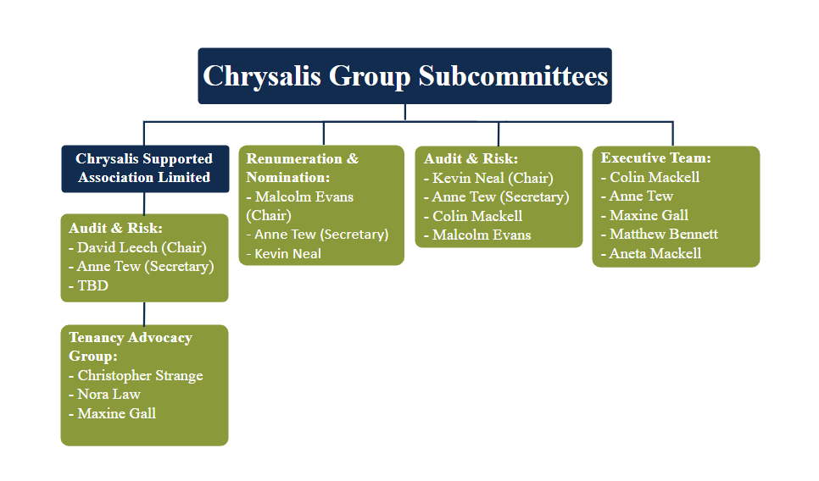

The organisation’s operations are centered at its group registered address:
- 3 Brook Office Park, Folly Brook Road, Emersons Green, Bristol.

This Governance Handbook provides further guidance about the conduct of Chrysalis within the regulatory framework outlined below. The Handbook is kept under review and updated to reflect changes in law, practice or policy – usually on an annual basis.

2.2 Regulatory Framework

The Charity Commission

CSA is an Exempt Charity. An exempt charity is an organisation established in England and Wales for charitable purposes which is exempt from registration with, and oversight by, the Charity Commission for England and Wales. Although outside the jurisdiction of the Charity Commission, exempt charities are still subject to the usual legal rules applicable to charities in English Law and to the general provisions of the Charities Acts, and may seek advice from the Charity Commission.

Opoka CIO is a Charitable Incorporated Organisation (CIO). A charitable incorporated organisation (CIO) is a corporate form of business designed for (and only available to) charitable organisations in England and Wales. All CIOs are registered charities and therefore have oversight by the Charity Commission for England and Wales and are subject to the usual legal rules applicable to charities in English Law and to the general provisions of the Charities Acts.

The Charity Commission is the independent charity regulator for England and Wales. Their role is to work with charities to ensure charities are accountable, well-run and meet their legal obligations. The Charity Commission aims are to promote public trust and confidence in charities and offers information and advice to registered charities on both legal requirements and best practice to help organisations operate as effectively as possible and to prevent problems arising.

The Regulator of Social Housing

CSA is a registered Social Housing Landlord. The Regulator of Social Housing (RSH) regulates registered providers of social housing (this includes housing associations, local authorities and for-profit providers). Focusing on governance, financial viability and value for money, as well as consumer standards, RSH ensures social housing providers are viable, efficient and well-governed.

The Regulator of Social Housing adopts a co-regulatory approach. It has statutory objectives in relation to economic and consumer matters and sets standards in both areas. Responsibility lies with the board to ensure that they meet the regulator’s standards. These standards only prescribe outcomes and expectations. Providers are free to choose how they will achieve those outcomes and expectations.

The Financial Conduct Authority

CSA is a provident mutual society and as such is registered with the Financial Conduct Authority (FCA). The FCA is a financial regulatory body in the United Kingdom, but operates independently of the UK Government. The FCA regulates financial firms providing services to consumers and maintains the integrity of the financial markets in the United Kingdom

Companies House

Chrysalis Group Services, Touchstone Developments and Investments Ltd and Blackfields Furniture Ltd are private limited companies and as such are registered with Companies House. This requires them to comply with the Companies Act.

The Compass Project CIC is a Charitable Incorporated Company (CIC). A CIC exists to help the public, they do not have “charitable purposes”. What’s important to note with a CIC is that although it looks like a charity, it is actually a company. This type of company was first introduced in 2005 under the Companies (Audit, Investigations and Community Enterprise) Act 2004, as an easy way for social enterprises to have the foundations of a company, but with additional features that allow it to be used for the benefit of the community whilst still being regulated by Companies House.

Relevant Legislation

All relevant legislation is recorded on the legal register to ensure the group is aware of its responsibilities within each piece of legislation is considered and can ensure requirements are complied with. This includes but is not limited to:
- Health and Safety legislation
- Employment legislation
- Social Housing legislation
- Data Protection legislation
- Safeguarding legislation
- Modern Slavery legislation
- Environmental legislation

A range of policies and procedures to meet the above legislation requirements have been implemented across the group.
2.3 Objects, Vision, and Values

One of the most important parts of the constitution of any type of organisation are its objects. As the name suggests, this is a list of aims and objectives, and includes (among other things) what each organisation is setting out to do, who or what will be the beneficiaries of its work, and how the organisation is to go about achieving what it wants to do.

The objects of every group organisation are listed in their governance document and if considered a charity, they must be 'charitable' as defined by law, and furthermore they must also fulfil the 'public benefit test' as set out in the Charities Act.

The objects of Chrysalis Supported Association (CSA) are set out in the Rules of Association. (Taken from Rules of Association, as amended June 2023, found in HM10).

Chrysalis Supported Association’s objects are:

- the provision of Social Housing, houses, hostels and such other types of accommodation as may be appropriate for the provision of abstinence based and other kinds of non-limited supported accommodation with support services (including without limitation, counselling, treatment and advice for people in recovery or seeking help from addiction and for those experiencing domestic violence);
- the advancement of education, training and skills to enable people in recovery from addition to re-engage with the wider community and obtain employment and improve their conditions of life;
- the furtherance of the charitable work of the Society (Chrysalis) by the advancement of such other charitable purposes as the directors shall from time to time decide.

The objects of Opoka CIC are set out in the Rules of the charity. (As amended June 2023)

Opoka CIC’s objects are:

- To promote the relief of women and their children or other persons (including but not limited to such women, children and other persons from within the Polish Community) who have been subject to domestic abuse, including physical or sexual violence; emotional, economic, financial or, coercive control: stalking;
- and/or misogynistic or other psychological abuse within an intimate or 'family' relationship throughout the United Kingdom, including by (but not limited to):
- the provision of specialist supported housing and social housing and any associated amenities and services; and
- the advancement of public education, research and training on the issues of domestic violence and gender-based violence throughout the United Kingdom.
- This is achieved through the delivery of the vision and strategy, supported by our values.

The objects of The Compass Project 2012 CIC are set out in the Articles of Association of the Company. (As amended June 2023)

The Compass Projects 2012 objects are:

- The objects of the Company are to carry on activities which benefit the community and in particular (without limitation) the relief of persons who are in need by reason of suffering from or at risk of suffering from substance misuse and other detrimental health risk behaviours.
- In this article 5 “detrimental health risk behaviour” means any form of individual behaviour which is harmful and self-detrimental, has a strong negative influence on health and which is attributable to poor psychological and social wellbeing for whatever reason, including substance misuse and other risks to individual health.

The Group Vision is

To grow and diversify as an ethically leading, customer-focused provider of high-quality supported housing and related services, leveraging our expertise and commercial activity, by attracting unique opportunities often alongside external investment.

The Group Mission is

To blend our commercial expertise, in order to support our group members towards growth and diversification, with a strong commitment to deliver social good, whilst safeguarding and promoting the wellbeing of our service users and communities across the UK, providing high-quality, sustainable products, services and homes.. These are supported by our Group values:

Integrity and Honesty – we will communicate our outcomes transparently so that all stakeholders know where we stand, and how we are performing against the standards and targets we set
Dependability and Commitment – all stakeholders can be assured that we will deliver on what we say we will, including maintaining your home, ensuring that tenants live in a good quality home, and that your safety is accounted for in line with the Tenants Charter. We will also deliver all related services and products to the same high standard.
Respect, Compassion and Humility – to demonstrate that we hear every voice, at every level throughout the organisation, especially those of our service users, ensuring that we take into account their views when making decisions, and designing services.
Courage and Responsibility – whatever the challenges are, we will remain accountable on delivering what we say we will, doing this to the best of our ability

We support all of this with the Strapline : “A safe home. A fresh start. A bright future.”

Our core operational values are Fairness, Honesty and Integrity.

Commitment to Equal Opportunities

Chrysalis Group actively drives equal opportunities for women to step into leadership and senior roles by identifying and removing barriers to equal access. We prioritise flexible working arrangements to support and enable advancement for all employees.

In addition, OPOKA CIO focuses on supporting women and children escaping domestic abuse so therefore operates under the exemption provided by Section 193 of the Equality Act 2010. As a result, OPOKA CIO ensures that all leadership, management, and board positions are held by women.

Value for Money

Value for money is much more than a financial statement. It is about looking at everything we do and making sure what we spend provides value for money and delivers a good return.

A Value for Money Framework will be established during 2024.

Section 3 – Roles and Responsibilities of Board members

3.1 Who can be a Board member? – Board member Eligibility based on charity and company requirements

Extract taken from, The Essential Trustee: what you need to know, what you need to do (CC3) May 2018
There are some restrictions on who can be a Board member – there are minimum age limits and some factors that automatically disqualify people from being Board members

- Board members must be properly appointed, and should know how long your appointment lasts
- if you are not properly appointed, the Board members’ decisions or actions may be invalid, potentially creating disputes or putting group assets at risk

Minimum age

Board members must be at least 16 years old to be a Board member of a charitable company or a charitable incorporated organisation (CIO), unless the governing document says you must be older.

Disqualification

You must not act as a Board member if you are disqualified under the Companies Act or Charities Act. Reasons for disqualification include if you:

• are disqualified as a company director
• have an unspent conviction for an offence involving dishonesty or deception (such as fraud)
• are an undischarged bankrupt (or subject to sequestration in Scotland), or have a current composition or arrangement including an individual voluntary arrangement (IVA) with your creditors
• have been removed as a Board member of any Society or charity by the Commission (or the court) because of misconduct or mismanagement

On 1 August 2018, new disqualification reasons were added: these will include being on the sex offenders’ register, unspent convictions for a wider range of offences including bribery and money laundering, or disobeying a direction of the Commission. The guidance below explains the changes in more detail.

Fit and proper persons

Charities that want to claim UK tax reliefs and exemptions (eg Gift Aid) within the Group must meet the management condition in the Finance Act 2010. This requires all of the managers of the Group (including Board members) to be ‘fit and proper persons’.

https://www.gov.uk/government/publications/charities-fit-and-proper-persons-test

Disclosure and Barring Service (DBS) checks

There are legal restrictions under safeguarding legislation on who can be involved in working with children and adults at risk. In addition, the DBS undertakes criminal records checks of individuals, which organisations can use to ensure that they are eligible and suitable for the Board member role. The type of check that can be made depends on the nature of the organisation’s activities and the role that the Board member plays. For example, if you are a Board member of a charity that provides ‘regulated activity’ for children or adults, you should expect your charity to request an enhanced DBS check on you: where it is satisfied that the role is eligible, this will include a check against the relevant barred list.

Conflicts of Interest

Chrysalis is committed to ensuring that principles of accountability, transparency and probity inform everything we do. Employees and board members will conduct themselves with integrity, trust and fairness.

In coming to decisions, the Boards of Chrysalis Group must act in the best interests of their relevant organisations and be mindful of actual or perceived conflicts between that organisation within the group on one hand and other group company’s best interests or their personal interests or other interests with which they might be associated, on the other.

Chrysalis Group has a documented Anti Bribery, Conflict of Interest & Impartiality Policy (CM08) which applies to all Board members and employees. An annual declaration is undertaken. An item allowing the declaration of any interests is included in template board meeting agenda (CT04))

3.2 Board Responsibilities

3.2.1 Legal Duties

The Chrysalis Group Services Board is the governing body of the Chrysalis Group, safeguarding its assets and applying them as efficiently and effectively as possible to further the objects as set out in each of the group’s members governing documents. The overriding duty of all Board members is to advance the purposes of Chrysalis Group.

Both Chrysalis Supported Associations and Opoka CIO have their own operating boards to ensure they make decisions in the best interests of those organisations and safeguard their assets. None of the group directors sit on these boards although can be invited to attend meetings.

In relation to the not for profit organisations within the group, board member responsibilities are often referred to as ‘The Six Legal Duties’. They are outlined in full in The Essential Board member (CC3). In summary they are:

- Ensure the Organisation is carrying out its purposes for the public benefit

Board members must make sure that the Organisation is carrying out the purposes for which it is set up, and no other purpose. This means Board members should:
- ensure they understand the Organisation’s purposes as set out in its governing document
- plan what the Organisation will do, and what the board want it to achieve
- be able to explain how all of the organisation’s activities are intended to further or support its purposes
- understand how the Organisation benefits the public by carrying out its purposes

See section 4 of the Essential Board member for more information.

- Comply with the Organisation’s governing document and the law
Board members must:
- make sure that the Organisation complies with its governing document
- comply with legal requirements that apply to your Organisation

See section 5 of the Essential Board member for more information.

- Act in the Organisation’s best interests
Board members must:
- do what you and your co-Board members (and no one else) decide will best enable the Organisation to carry out its purposes
- with your co-Board members, make balanced and adequately informed decisions, thinking about the long term as well as the short term
- avoid putting yourself in a position where your duty to your Organisation conflicts with your personal interests or loyalty to any other person or body
- not receive any benefit from the Organisation unless it is properly authorised and is clearly in the Organisation’s interests; this also includes anyone who is financially connected to a Board member, such as a partner, dependent child or business partner
See section 6 of the Essential Board member for more information.

- Manage the Organisation’s resources responsibly
Board members must act responsibly, reasonably and honestly. This is sometimes called the duty of prudence. Prudence is about exercising sound judgement. Board members must:

- Protect and promote the interests of their residents and the communities they serve, while safeguarding public and private investment in social housing and maintaining public trust in the sector
- make sure the Organisation’s assets are only used to support or carry out its purposes
- avoid exposing the Organisation’s assets, beneficiaries or reputation to undue risk
- not over-commit the Organisation
- take special care when investing or borrowing
- comply with any restrictions on spending funds or selling land

Board members should put appropriate procedures and safeguards in place and take reasonable steps to ensure that these are followed. Otherwise you risk making the Organisation vulnerable to fraud or theft, or other kinds of abuse, and being in breach of your duty.
See section 7 of the Essential Board member for more information.

- Act with reasonable care and skill

Board members:
- must use reasonable care and skill, making use of your skills and experience and taking appropriate advice when necessary
- should give enough time, thought and energy to your role, for example by preparing for, attending and actively participating in all Board members’ meetings
See section 8 of the Essential Board member for more information.

- Ensure the Organisation is accountable
Board members must comply with statutory accounting and reporting requirements. Board members should also:
- be able to demonstrate that your Organisation is complying with the law, well run and effective
- ensure appropriate accountability to members, if your Organisation has a membership separate from the Board members
- ensure accountability within the Organisation, particularly where you delegate responsibility for particular tasks or decisions to staff or volunteers
See section 9 of the Essential Board member for more information.

- Duties of a Company Director

The Companies Act determines similar duties. The board of directors are typically responsible for the day-to-day operations of a company whilst shareholders are often only involved where fundamental decisions are being made. Generally speaking, this distinction makes the board the most important decision maker of a company.

In light of this, directors are bound by legal duties and obligations which they owe the company. The Companies Act 2006 (“CA 2006”) codifies seven key duties that every director of a company is bound by. These are all ‘high level’ so that there is room for interpretation and further development through the courts. These statutory duties apply to every legal director of a company whether they are a managing director, a non-executive director (NED), an investor director or a shadow director.

There are seven statutory directors’ duties set out in the CA 2006. These are owed to the company rather than to any individual shareholders:

• Duty to act within their powers (s.171 CA 2006)
• Duty to promote the success of the company for the benefit of its members (shareholders) as a whole (s.172 CA 2006)
• Duty to exercise independent judgement (s.173 CA 2006)
• Duty to exercise reasonable care, skill, and diligence (s.174 CA 2006)
• Duty to avoid conflicts of interests (s.175 CA 2006)
• Duty not to accept benefits from third parties (s.176 CA 2006)
• Duty to declare interests in proposed transactions or arrangements with the company (s.177 CA 2006)
It is important to note that in addition to the above, there are other duties which a director will need to ensure compliance with, for example, ensuring proper implementation of employee health and safety procedures or ensuring the company is not trading wrongfully or fraudulently.

3.2.2 Financial Responsibilities of the Board members

The board has some key financial responsibilities.

Financial planning

The board will agree a budget annually and then ongoing forecasts update the planned income and expenditure throughout the year. The budget sets out the expenditure you plan to make and the income you expect to raise. The board monitors at each board meeting the actual performance against the budget and latest forecast. Agreeing and monitoring the budget is a key way in which the board ensures that income and any assets the organisation may have are used to further the organisation's aims. Group Board members have a duty to ensure that the organisation's resources for each not for profit group member are only used to further their objects.

The board also needs to monitor its cashflow as it has duty to avoid becoming insolvent. It is advisable to hold reserves to meet your outgoings and the board has a provision policy in relation to Chrysalis Supported Association.

In addition to an annual budget, a longer-term plan or strategy can build the organisation's financial strength. Many charities and non-profits rely on just a few sources of income, making them vulnerable if these dry up. It's a good idea for the board to explore how it can diversify its sources of income.

Financial controls

The boards should ensure that there are proper controls in place to ensure money can be accounted for and not misused. The extent of the controls you need will depend on the size and scale of your organisation ranging from procedures for authorising expenditure and setting out who has signing authority through to a full financial regulations (FM02)

The Charity Commission has published guidance on internal financial controls.

Financial reporting

The board needs good financial information to understand the financial health of the organisation. It is particularly important that you keep an eye on the cash flow to ensure your organisation is not in danger of becoming insolvent.

In addition to internal reports all organisations within the group will also prepare annual external accounts. Both CSA and Opoka undertake a full audit in additions with a full review of the group accounts.

If you are regulated by other bodies you may also have to provide financial reports to them for example to Companies House, the CIC regulator, or the FSA.

The Charities Commission requires charities with over £25,000 of income to have their accounts independently examined and those with an income over £1m fully audited. We usually opt to have an audit for our non for profit organisations.

3.2.3 Main tasks of Board members

- To lead the organisation within Chrysalis, establish its mission, vision and values and ensure it has a clear purpose and an overall framework of policies and standards.
- To develop overall strategies to achieve the Group’s aims and to ensure there is a clear system to delegate implementation of the strategies to the Chief Executive, Other Executive Directors and employee team.
- To monitor performance of the Group against standards that ensures effective, efficient and economic use of the Group’s resources and assets.
- To ensure compliance with the law and accountability to the Group’s stakeholders and provide transparency in performance of their actions
- To ensure the Board performs effectively, contains people with the skills and experience it needs, and makes plans to ensure the recruitment, induction and development of new Board members.
- To Set and ensure compliance with the Group Risk Framework (CM05)

Strategy & Policy

- Approve the strategic objectives, the strategy to achieve them and overarching policies.
- Satisfy itself that management is implementing agreed strategic planning and policy development processes.
- Provide an independent challenge of management’s key assumptions and assess whether the management’s strategy is reasonable in relation to the risks involved, the resources required and the benefits to be achieved.
- Agree the parameters on which the annual and longer-term budgets are based and agree budgets and a reserves policy that supports the strategy.

Policy & Procedures

- Clear policies to ensure good governance should be approved at board level for each organisation within the group.
- Specific policies to meet the regulatory requirements specific to an organisation within the group may be agreed by the relevant board.
- Policies relating to group wide support or activities such as HR or Data Protection will be set at group level to ensure consistency and to meet the regulatory requirements of all group organisations and approved independently by each board.

Management effectiveness and succession

- Constructively question, test and challenge management’s views and proposals.
- Monitor management’s performance against the agreed intentions, strategy and objectives.
- Establish and review clear written terms of reference setting out the decision-making authority that is delegated to the Executive team.
- Take an active role in the recruitment of the Chief Executive and, by invitation, the Executive Team, monitor performance against specified goals, set remuneration and if necessary, undertake any grievance or disciplinary action.

Internal control and management information systems

The Board will ensure that management has implemented effective internal control systems and management information that enable it to evaluate:

- Operational effectiveness and efficiency.
- Compliance with legislation and regulations.
- Compliance with the Group’s own policies and procedures.
- The reliability of management and financial information.
- Performance of the Group’s services.
- Quality of the Group’s services.
- Asset and investment management.

Risk identification and management

The Board will ensure that management has implemented an effective process to identify (where appropriate and possible) monitor and manage the potential risks facing Chrysalis.

Delegation

As per the requirements of all group companies, the Board will:
- Create or dissolve such sub-committees as it deems necessary to advise it and deal with specific areas of its responsibility.
- Delegated authority to sub committees is undertaken within clear terms of reference.

Development and Board Effectiveness

The Board of Board members will:
- Annually review its own performance and effectiveness and that of the Chief Executive through Board member “check-ins”/appraisals
- Ensure the induction and development of all Board members
- Conduct regular internal and external board evaluation and subscribe to the principle of continuous improvement.
- Encourage Board member development through internal training, briefings and attendance at external courses.

Serious Incidents, Safeguarding, Whistleblowing and Privacy

Chrysalis Group has documented policies on how Board members are responsible (and accountable) for reporting serious incidents, safeguarding and protecting people from harm, whistleblowing and protecting privacy. These policies are regularly reviewed in line with best practice and updates to legislation.

Impact

Board members will ensure that Chrysalis is achieving its aims. Board members need to be confident that the organisation’s activities are really making a difference to the lives of those they are intended to benefit. Board members can assist by ensuring they agree appropriate targets, and ways of regularly tracking and assessing progress. It’s important to focus on the outcomes for your users rather than simply the size or scale of your activities. You need to look beyond efficiency to effectiveness.

3.2.4 Operation and structure

Subject to the overriding provision of individual organisation governing documents, the following shall apply to the operation and structure of the Board.

Number and quorum

This is currently fixed at present to:

- Quorum: as stated by the Rules within the governing document for each organisation.

- Maximum Number of Board Members: The Group shall have a Board of directors which shall manage the business of the Group. Chrysalis Supported Housing Association and Opoka CIC will have their own board of directors/trustees to manage their own matters and ensure they act in the best interest of those organisations. The Boards shall consist of not less than three nor more than twelve directors, or such other number as may be determined in general meeting.

The Board will represent the key skills involved in delivering its services see section 4 for more detail.

Officers

Appointments and retirement of directors

Term of office

All NEDs will be appointed for terms of three years and subject to re-appointment and to statutory provisions relating to the removal of a director. Usually maximum terms will not exceed 9 years, except in special circumstances for a non-executive director. Terms beyond this will be subject to particularly rigorous review. One third of the Board resigns annually, and is subsequently re-elected should they so wish, subject to Board approval.

Meetings and reporting

The Board shall meet at least four times per year. There will also be an additional strategy planning meeting per year and ongoing board development sessions to improve board effectiveness.

Conduct and Reporting

Minutes of the Board meeting will be taken by the Group Company Secretary, amended as appropriate and approved, and then signed by the Chair, at the following meeting.

Expenses

As defined within the Financial Procedures and Regulations board members can claim legitimate expenses.

Decision-making outside Board meetings

Where circumstances dictate that a Board decision is required before the next scheduled meeting, agreement by email form members of the board can be obtained. A majority response is considered sufficient as long as all board members are on the email. Key decisions agreed between board meetings should be included in the minutes of the next full board meeting.

In all the above cases, consideration shall be given to the balance between the need for urgency with the overriding principle that each Board member should be given:
- As much information as possible.
- The time to consider it properly.
- The opportunity to discuss the matter prior to the commitment of the Organisation.

3.3 Delegation of Authority

Matters which the Boards consider suitable for delegation are contained in the terms of reference of its Committees. However, where statute, regulation or the any of the Organisation’s Rules dictate, the final decision is reserved for the Board.

For the avoidance of doubt, any powers not specifically mentioned above shall be the responsibility of the Chief Executive who may delegate them as he/she considers appropriate.

Constraints on the Group Chief Executive and Executive Directors

- Not to act in contravention of the general law or the Rules of any of the Group’s organisations.
- Not to adjust staffing levels outside of the approved establishment.
- Not to deviate from the policies and procedures of the Group.
- Not to authorise activity or commit resources outside of agreed delegation levels or budgeting provision or guidelines.
- Not to allow any activity or practice which is contrary to commonly accepted professional practice in the sector.
- Not to say or do anything which may bring Chrysalis into disrepute.

3.4 Role Descriptions

Board Purpose

It is the duty of the Board to act in the interest of the Organisation and any subsidiary’s beneficiaries therefore as a Board member you should work with the Board to ensure the Group has a clear strategic direction and purpose. As a collective, Board members should set clear objectives, establish priorities and safeguard assets.

3.4.1 Executive Director

Purpose

It is the duty of the executive members of the Board to carry out the decisions agreed by the board and manage the implementation of policies and agreed strategic objectives. Executive Directors have the responsibility to manage their areas and staff in the best interest of the organistions and to achieve the outcomes required.

3.4.1 Non-Executive Director

Purpose

Non-Executive Directors should be independent of the day to day operations and therefore act as an independent voice within the board. They should scrutinise that the executive team are carrying out what the board has agreed as a whole and ensure that risks are managed through the committee structure. Directors should not act independently unless they have clear instruction to do so from the Chair.

For the Role description see (HRJD02)

3.4.2 Chair of the Board

Purpose

The role of the Chair is to lead the Board, ensuring that it fulfils its responsibilities for the governance of the organisation and its subsidiaries and to work in partnership with the Group Chief Executive to achieve the aims of the Group.

See the Chair role description (HRJD03)

3.5 Code of Conduct

All board members, within every Group Board, have legal duties and responsibilities which are laid down in the Board members’ Roles and Responsibilities. The Chrysalis Code of Conduct Policy goes beyond the legal requirements and is consistent with the recommended principles to which those in public life should adhere – selflessness, integrity, objectivity , accountability, openness, honesty and leadership.

All board members respect the Group values and beliefs and those laid down in the Charity Governance Code, and the NHF’s Code of Governance.

The purpose of this Code is to set out the relevant standards and commitments expected of Board members in the fulfilment of their duties. Adherence to the standards will help to ensure the effectiveness of the Organisations to maintain openness and accountability across the Group. It will also serve to support the positive working relationships between Board members and the Chief Executive and the rest of the executive team.

Chrysalis Group’s Code of Conduct Policy can be found in the quality manual CM03

Section 4 Board Recruitment

4.1 Overview

The Group’s Boards must always be well equipped to carry out their governance responsibilities.

The collective skills, experience, competencies, and personal qualities of each Board Director must be sufficient to provide good governance. New Directors will be provided with sufficient knowledge and information of the company to enable them to discharge their respective duties and responsibilities effectively.

The Boards should have the appropriate balance of skills, experience, and independence at all times. The main objective of this policy is to keep the group’s boards refreshed with the required skills and experience, and aligned with the current and future business strategy in a way that clearly demonstrates compliance with:

- The Charity Governance Code; and,
- The Regulator of Social Housing (RSH) Regulatory requirements.
- The Companies Act
- The Financial Conduct Authority

Plans will also be put in place for orderly succession for appointments to each board, so as to maintain an appropriate balance of skills and experience within the company and on the board and to ensure progressive refreshment of the Board.

It is recognised that the Board membership should reflect the needs of each organisation within the group. These should broadly include:

- Supported/specialist housing experience and expertise, particularly within the Chrysalis Supported Association Board
- Charity experience
- Legal knowledge and expertise
- Financial knowledge and skill
- Business/commercial experience and acumen

The Group ensures that it operates in accordance with the Equality Act of 2010 and, more broadly, offers equality of opportunity for all who come into contact with the Group regardless of their diverse personal characteristics. Our Equality, Diversity and Inclusion Policy is regularly reviewed and contains a section specifically on the recruitment of volunteers and the value of diversity.

Chrysalis Group Services’ Board will lead the process for board appointments.

All Members will be appointed based on the skills and experience they bring to the Board.

Independent non-executive directors (NEDs) are specifically appointed for their expertise or knowledge in particular areas which the Board deems necessary for its effective performance.

All NEDs will be appointed for terms of three years and subject to re-appointment and to statutory provisions relating to the removal of a director. Usually maximum terms will not exceed 9 years, except in special circumstances for a non-executive director. Terms beyond this will be subject to particularly rigorous review.

All Board Director appointments made during the year are subject to confirmation at the next Annual General Meeting (AGM).

4.2 Induction, Training and Development Support for NEDs

Chrysalis Group will support NEDs on all boards with a programme of induction and board development training.

The induction programme will be undertake by each NED and undertaken by the Chair of Board and the Group Company Secretary.

In addition, a training programme for NEDs will be arranged annually by the Company Secretary and new NEDs will join the board development training programme upon appointment.

All NEDs are expected to keep their skills up to date by attending appropriate training events and conferences provided by and / or funded by the Group.

4.3 Annual Reviews , Skills Analysis and Support

All NEDs will engage in an annual appraisal with the process agreed from time to time by either the Board. The collective feedback will be fed into a training plan and effectiveness reviews for the Board.

4.4 Skills Evaluation

To enable an effective succession plan to be developed and implemented, a regular evaluation of skills will take place, usually on an annual basis, and a board development plan implemented to address any gaps.

The board should consider the balance of skills, experience, independence and knowledge of the company on the board, its diversity, how the board works together as a unit, and other factors relevant to its effectiveness.

Any gaps identified will be added to the board development training program.

4.5 Succession Planning

The Boards will be proactive in looking at its future needs in terms of Board composition, skills and experiences to ensure that they retain the ability to discharge its duties effectively. It will also consider how the Boards reflects the diversity of the communities within which they work. They will also ensure that they comply with their Rules and regulations as well as consider from time to time how they would deal with situations such as Force Majeure and agree the preferred approach.

The Chair of each Board with the Group nomination and remuneration committee will be proactive in ensuring that succession arrangements for both the Chair and for each Board as a whole are in place.

Board Members will typically be appointed for three-year terms subject to an annual appraisal after one year. However, in order to ensure good succession planning, a term of office may be varied. This is designed to ensure that large numbers of NED vacancies do not have an adverse effect on the overall skills, knowledge and experience on the individual bards and their governance structure.

The boards will utilise succession plans to consider different time horizons. These include:
- Contingency planning – for sudden and unforeseen departures;
- Medium-term planning – the orderly replacement of current board members and senior executives (e.g. retirement); and,
- Long-term planning – the relationship between the delivery of the corporate strategy and objectives to the skills needed on the board now and in the future

The succession plans will also be used to restate diversity objectives; to emphasise the breadth of diversity (i.e. not just gender and race); to state the business case for board diversity; to outline the relationship between board and executive; and to set out targets, if appropriate, including how to achieve and review these.

4.6 Continuity and Succession

While the importance of identifying and introducing new talent to Chrysalis Group Boards is recognised, the Group shall have in mind the option to provide development opportunities for existing Independent Members.

To facilitate the above, opportunities will be given to enhance the skills of existing NEDs and Independent Members through training, conferences and mentoring.

Wherever possible and practical, we would seek for outgoing board members to be shadowed by prospective successors, ideally for a minimum term of 3 months prior to their retirement. This will ensure a comprehensive handover and compliment any induction and/or training program.

Particular Roles

  - The Chair of each board: is appointed with a specific term of office. The succession planning for the role will fit around that term. It is the responsibility of a nominated NED, to lead on the annual appraisal of the Chair. The Group CEO will facilitate the process to recruit a new Chair in conjunction with the Group Nomination and Remuneration Committee. The retiring Chair will not play any part in the recruitment of their successor and shall vacate all board roles within the Group at that point.

  - The Group Nomination and Remuneration Committee Chair should commence the succession process for a new Chair, at least 12 months before the expiry of the current Chair’s term of office.

  - The Group CEO will work with the relevant Board and Group Committee to plan and recruit to the Chair role, in accordance with the board recruitment policy.

Responsibilities

  - The relevant Chair:
- Has overall responsibility for recognising the strengths and addressing the weaknesses of the board and, where appropriate, proposing the appointment of new directors to the board or seeking the resignation of existing directors; and,
- Has responsibility for ensuring that the performance of the Board overall is kept at the optimum level and that may require interventions outside of the normal term cycle of individual NEDs in line with the annual collective performance evaluation.

  - The Group Board will be responsible for:

- Evaluating the balance of skills, experience, independence and knowledge on the board and, in the light of this evaluation, prepare a description of the role and capabilities required for a particular appointment;
- Undertaking recruitment, including appointing independent search/ recruitment consultants where required;
- Reviewing the size, structure and composition of the Board, including knowledge, experience and diversity, and making recommendations to the Board with regard to any changes;
- Developing and reviewing objectives for the implementation of board diversity, and monitoring progress;
- Deciding the continuation in office of board directors;
- Commissioning board effectiveness reviews;
- Setting the processes for the recruitment and appointment of NEDs and giving advice on this issue to the Board as appropriate;
- Identifying and nominating candidates, based on skills and competencies appropriate to the business and its direction and against objective criteria, for approval by the Board (except the Chair which shall be a matter for the whole Board), using external advisers as required;
- Deciding on the re-appointment of any non-executive board director or independent member at the conclusion of their specified term of office;
- Reporting its own work in a distinct section of the annual report. This will include descriptions of the process it has used in relation to board appointments.

Section 5 – Governing Documents - Rules of Group Companies

5.1 Chrysalis Group Services Articles of Association

Chrysalis Group Services Limited is a company registered at companies house under number 14621546 operating under standard Company Act articles (CM13). Chrysalis Group Limited is registered in England and Wales as an exempt charity (XR95728).

  - Chrysalis Supported Association Rules
Chrysalis Supported Association is registered under number IP29818 Chrysalis under the Co-operative and Community Benefit Societies Act 2014 set up for the benefit of the community as a not-for-profit organisation, regulated by the Financial Conduct Authority (FCA) and therefore has to comply with the FCA regulations for such bodies. It is regulated by an approved set of rules registered and approved by the FCA (CM11)

Chrysalis Supported Association is also a Non-Profit Private Registered Provider of Social Housing Registered Number: 4751, Regulated by The Regulator of Social Housing (RSH). CSA are members of the Housing Ombudsman and subscribe to their standards of complaints management and fair practice procedures for all tenants.

  - Touchstone Developments & Investments Limited Articles of Association

Touchstone Developments & Investments Limited is a company registered at companies house under number 12620397 operating under standard Company Act articles (CM13)

  - Opoka CIO Rules

Opoka Charitable Incorporated Organisation is registered with the Charities Commission under number 1195206 operating under rules lodged with the commission (CM15)

OPOKA CIO operates under the exemption provided by Section 193 of the Equality Act 2010. As a result, OPOKA CIO ensures that all leadership, management, and board positions are held by women.

  - Compass Project 2012 CIC

Compass Project 2012 is a Charitable Incorporated Company registered with Companies House under number 08043211 operating under specific Articles lodged with Companies House (CM12).

Section 6 – Improving Governance

Strong governance is essential for the success, accountability, and long-term success of Chrysalis Group, particularly as it includes not-for-profit entities. Effective governance ensures strategic alignment across all subsidiaries, enhances decision-making, and mitigates risks while maintaining compliance with regulatory and ethical standards.

As the organisations grow, a well-structured governance framework ensures consistency and the ability to adapt to evolving challenges while staying true to Chrysalis Group’s overarching purpose.

6.1 Registers

We make use of a set of registers including Legal Register, Contract Register, Corporate Register. to help track compliance of Chrysalis Group.

By implementing and maintaining these governance tools, we improve risk management and compliance with legal obligations, in addition to demonstrating accountability and reinforcing the integrity of the Group.

The Legal Register helps track compliance of with laws and regulations. It is split into separate sections for each organisation. It is used to ensure that all organisations adhere to statutory requirements.

The Contract Register provides an oversight of agreements, noting the relevant dates, the signee, key responsibilities and any comments. It is split into separate sections for each organisation.

The Corporate Register is used to maintain all records of company structure, directorships, ownership details etc. It is helpful in maintaining transparency throughout the Group.

Related Documents
CM03 | Group Code of Conduct
CM05 | Group Risk Management Framework
CM08 | Anti Bribery, Conflict of Interest & Impartiality Policy
CM09 | Nomination and Renumeration Committee Group TORs
CM10 | Treasury, Audit and Risk Committee Group TORs
CM10a | Treasury, Audit and Risk Committee CSA TORs
CM13 | Model Articles – CSA & CGS and non trading companies
CM15 | OPOKA CIO Constitution
CM20 | Executive Committee Group TORs
FM02 | Group Financial Regulations
CT04 | Board Agenda Template
HM10 | CSA – CBS rules
OM05 | Women-led Executive Leadership Policy

